How to log API End Point execution time with global filter

For the logging here, log4net used – please use logging mechanism as per your need or add log4net package in your WebAPI project



Step 1: Create a class in WebAPI project “EndPointExecutionTimeFilter”

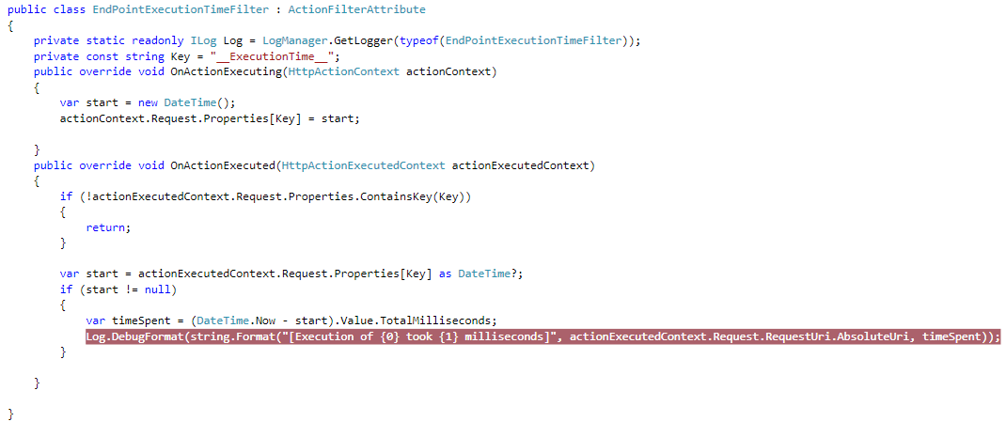

Step 2: Register above filter attribute globally

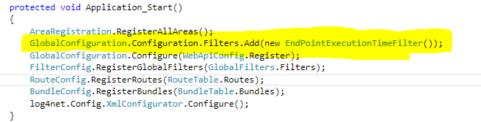

Step 3: Run the project, hit the endpoint – find the log in log file



Thanks